UNIT #1 – Polynomial Functions and Expressions
Lesson | Key Concept & Strategy | Textbook
1  Power Functions | ●recognize a polynomial expression (i.e., a series of terms where each term is the product of a constant and a power of x with a nonnegative integral exponent, such as x³ – 5x² + 2x – 1)  ●recognize the equation of a polynomial function, give reasons why it is a function, and identify linear and quadratic functions as examples of polynomial functions | P.11 #1-8
2  Characteristics of Polynomial Functions:  Part I | ●describe key features of the graphs of polynomial functions (e.g., the domain and range, the shape of the graphs, the end ehavior of the functions for very large positive or negative x-values)  ●Sample problem:  Describe and compare the key features of the graphs of the functions  f(x) = x, f(x) = x² , f(x) = x³ , f(x) = x³ + x² , and f(x) = x³ + x. | Investigation #1  Page 15-17  P. 26#1,2,5,6,10  *Need Graphing Calculators
3  Characteristics of Polynomial Functions:  Part II | ● compare finite differences in tables of values  ● compare, through investigation using graphing technology, the numeric, graphical, and algebraic representations of polynomial (i.e. linear, quadratic, cubic, quartic) functions(e.g., compare finite differences in tables of values; investigate the effect of the degree of a polynomial function on the shape of its graph and the maximum number of x-intercepts; investigate the effect of varying the sign of the leading coefficient on the end behaviour of the function for very large positive or negative x-values)  ●Sample problem:  Investigate the maximum number of x-intercepts for linear, quadratic, cubic, and quartic functions using graphing technology. | Investigation #2  Page 17,18  P. 26  #3,4,7,8,12,15-17  *Need Graphing Calculators
4  Equations & Graphs of Polynomial Functions | ● determine an equation of a polynomial function that satisfies a given set of conditions (e.g. degree of the polynomial, intercepts, points on the function), using methods appropriate to the situation (e.g., using the x-intercepts of the function; using a trial-and-error process with a graphing calculator or graphing software; using finite differences), and recognize that there may be more than one polynomial function that can satisfy a given set of conditions (e.g., an infinite number of polynomial functions satisfy the condition that they have three given x-intercepts)  ●Sample problem:  Determine an equation for a fifth-degree polynomial function that intersects the x-axis at only 5, 1, and –5, and sketch the graph of the function.  ●make connections, through investigation using graphing technology (e.g., dynamic geometry software), between a polynomial function given in factored form [e.g.,f(x) = 2(x – 3)(x + 2)(x – 1)] and the x-intercepts of its graph, and sketch the graph of a polynomial function given in factored form using its key features (e.g., by determining intercepts and end behaviour; by locating positive and negative regions using test values between and on either side of the x-intercepts)  ●Sample problem:  Investigate, using graphing technology, the x-intercepts and the shapes of the graphs of polynomial functions with one or more repeated factors, for example,  f(x) = (x – 2)(x – 3),  f(x) = (x – 2)(x – 2)(x – 3),  f(x) = (x – 2)(x – 2)(x – 2)(x – 3), and  f(x) = (x + 2)(x + 2)(x – 2)(x – 2)(x – 3), by considering whether the factor is repeated an even or an odd number of times. Use your conclusions to sketch f(x) = (x + 1)(x + 1)(x – 3)(x – 3), and verify using technology. | Investigation #3  Page 30 #1 to 5c)  (omit #4b)  P. 39  #1,2,6,9,11  *Need Graphing Calculators
5  Even/Odd Functions | ●determine, through investigation, and compare the properties of even and odd polynomial functions [e.g., symmetry about the y-axis or the origin; the power of each term; the number of x-intercepts; f(x) = f(– x) or f(– x) = – f (x)], and determine whether a given polynomial function is even, odd, or neither  ●Sample problem:  Investigate numerically, graphically, and algebraically, with and without technology, the conditions under which an even function has an even number of x-intercepts. | P.39#3,4,5,8,12b
6  Transformations | ●determine, through investigation using technology, the roles of the parameters a, k, d, and c in functions of the form y = af (k(x – d)) + c, and describe these roles in terms of transformations on the graphs of f(x) = x³ and f(x) = x⁴ (i.e., vertical and horizontal translations; reflections in the axes; vertical and horizontal stretches and compressions to and from the x- and y-axes)  ●Sample problem:  Investigate, using technology, the graph of f(x) = 2(x – d)³ + c for various values of d and c, and describe the effects of changing d and c in terms of transformations. | P.50#5-10,12ac,13
7  Average Rate of Change | ●gather, interpret, and describe information about real-world applications of rates of change, and recognize different ways of representing rates of change (e.g., in words, numerically, graphically, algebraically)  ●sketch a graph that represents a relationship involving rate of change, as described in words, and verify with technology (e.g., motion sensor) when possible  ●Sample problem:  John rides his bicycle at a constant cruising speed along a flat road. He then decelerates (i.e., decreases speed) as he climbs a hill. At the top, he accelerates (i.e., increases speed) on a flat road back to his constant cruising speed, and he then accelerates down a hill. Finally, he comes to another hill and glides to a stop as he starts to climb. Sketch a graph of John’s speed versus time and a graph of his distance traveled versus time | P.62#1,3-6,8
8  Instantaneous Rate of Change | ●gather, interpret, and describe information about real-world applications of rates of change, and recognize different ways of representing rates of change (e.g., in words, numerically, graphically, algebraically)  ●sketch a graph that represents a relationship involving rate of change, as described in words, and verify with technology (e.g., motion sensor) when possible | Pg 71  #1,2a,3,7,9,11,12
9  Review | Day 1  Day 2 | Ch 1 Review  Pg 74 #1–18 (omit#1c)  Ch 1 Practice Test  Pg 78 #1-13

UNIT #2 – SOLVING POLYNOMIAL EQUATIONS/SOLVING INEQUALITIES
Lesson | Key Concept & Strategy | Textbook
1  Dividing Polynomials | ●make connections, through investigation using technology (e.g., computer algebra systems),between the polynomial function f(x), the divisor x – a, the remainder from the division f(x)/( x – a) , and f(a) to verify the remainder theorem and the factor theorem  ●Sample problem:  Divide f(x) = x⁴ + 4x³ – x² – 16x – 14 by x – a for various integral values of a using a computer algebra system. Compare the remainder from each division with f(a). | P.91 #1acd, 3  4a, 5
2  Remainder Theorem | ●solve problems involving applications of polynomial and simple rational functions and equations [e.g., problems involving the factor theorem or remainder theorem, such as determining the values of k for which the function f(x) = x³ + 6x² + kx – 4 gives the same remainder when divided by x – 1 and x + 2]  ●Sample problem:  Use long division to express the given function  f(x) = (x² + 3x – 5)/( x – 1) as the sum of a polynomial function and a rational function of the form A/( x – 1) [where A is a constant], make a conjecture about the relationship between the given function and the polynomial function for very large positive and negative x-values, and verify your conjecture using graphing technology. | P.91#8a,9d,10,12,14,  20,22
3  Factor Theorem | ●remainder theorem, factor theorem  ●Sample problem:  Factor: x³ + 2x² – x – 2; x⁴ – 6x³ + 4x² + 6x – 5.  ●factor polynomial expressions in one variable, of degree no higher than four, by selecting and applying strategies (i.e., common factoring, difference of squares, trinomial factoring, factoring by grouping, remainder theorem, factor theorem)  ●Sample problem:  Factor: x³ + 2x² – x – 2; x⁴ – 6x³ + 4x² + 6x – 5 | P.102#1ac,2b,3a  6ace,8,9,11abf  4ad,15
4  Solving Polynomial Equations & Family of Polynomial Functions | ●solve polynomial equations in one variable, of degree no higher than four (e.g. 2x³ – 3x² + 8x – 12 = 0), by selecting and applying strategies (i.e., common factoring, difference of squares, trinomial factoring, factoring by grouping, remainder theorem, factor theorem), and verify solutions using technology (e.g., using computer algebra systems to determine the roots; using graphing technology to determine the x-intercepts of the graph of the corresponding polynomial function)  ●determine the equation of the family of polynomial functions with a given set of zeros and of the member of the family that passes through another given point [e.g., a family of polynomial functions of degree 3 with zeros 5, –3, and –2 is defined by the equation f(x) = k(x – 5)(x + 3)(x + 2), where k is a real number, k ≠ 0; the member of the family that passes through (–1, 24) is f(x) = –2(x – 5)(x + 3)(x + 2)]  ●Sample problem:  Investigate, using graphing technology, and determine a polynomial function that can be used to model the function f(x) = sin x over the interval 0 ≤ x ≤ 2л. | P.110#1ac,2ac,4a,5,6ace,  7ac,8a,11,17,18  P.119#1,2,3,7,14
5  Solving Polynomial Inequalities:  Graphically | determine solutions to polynomial inequalities in one variable [e.g., solve f(x) ≥ 0, where f(x) = x³ – x² + 3x – 9] and to simple rational inequalities in one variable by graphing the corresponding functions, using graphing technology, and identifying intervals for which x satisfies the inequalities | P.129#1,2ab,3,5ad,6abce,  10,13
6  Solving Polynomial Inequalities: Algebraically  N.B : No imaginary roots when solving | ●solve linear inequalities and factorable polynomial inequalities in one variable (e.g., x³ + x² > 0) in a variety of ways (e.g., by determining intervals using x-intercepts and evaluating the corresponding function for a single x-value within each interval; by factoring the polynomial and identifying the conditions for which the product satisfies the inequality, and represent the solutions on a number line or algebraically (e.g., for the inequality x⁴ – 5x² + 4 < 0, the solution represented algebraically is  – 2 < x < –1 or 1 < x < 2,xeR)  ● [include algebraic (# line theory)] | P.138#1bcf,2,4ad,5abd,  7ab
7  Review |  | Chapter 2 Review  Page 140# 1a,2ab,3,4ab,  6,7,8,10,12,14,15ac,  17a,18a  Chapter 2 Practice Test  Page 142# 1,2,6a,7,  8ab,9a,10,11,12,14a,  15a,16ab,17

UNIT #3 – RATIONAL FUNCTIONS, EQUATIONS, and INEQUALITIES

1  Reciprocal of a Linear Function | ●sketch the graph of a simple rational function using its key features, given the algebraic representation of the function  ●determine, through investigation using technology (e.g., graphing calculator, computer algebra systems), the connection between the real roots of a rational equation and the x-intercepts of the graph of the corresponding rational function, and describe this connection [e.g., the real root of the equation (x – 2)/(x – 3)= 0 is 2, which is the x-intercept of the function  f(x) = (x – 2)/(x – 3) ; the equation 1/(x – 3) = 0 has no real roots, and the function f(x) = 1/(x – 3) does not intersect the x-axis]  ●solve simple rational equations in one variable algebraically, and verify solutions using technology (e.g., using computer algebra systems to determine the roots; using graphing technology to determine the x-intercepts of the graph of the corresponding rational function) | In class Investigation-handout  Page 154#1a, 2, 3, 5, 7cf, 8, 9
2  Reciprocal of a Quadratic Function | ●determine, through investigation with and without technology, key features (i.e., vertical and horizontal asymptotes, domain and range, intercepts, positive/negative intervals, increasing/decreasing intervals) of the graphs of rational functions that have linear expressions in the numerator and denominator [e.g., f(x) = 2x/(x-3), h(x) = (x-2)/(3x +4], and make connections between the algebraic and graphical representations of these rational functions  ●Sample problem:  Investigate, using graphing technology, key features of the graphs of the family of rational functions of the form f(x) = 8x/(nx+1) for n = 1, 2, 4, and 8, and make connections between the equations and the asymptotes. | In class Investigation-Handout  Page 165# 1b, 2abcf,5be, 7c, 8aeh, 11
3  Rational Functions (linear over linear) | ●determine, through investigation with and without technology, key features (i.e., vertical and horizontal asymptotes, domain and range, intercepts, positive/negative intervals, increasing/decreasing intervals) of the graphs of rational functions that are the reciprocals of linear and quadratic functions, and make connections between the algebraic and graphical representations of these rational functions [e.g. make connections between f(x) = 1/( x²- 4) and its graph by using graphing technology and by reasoning that there are vertical asymptotes at x = 2 and x = –2 and a horizontal asymptote at y = 0 and that the function maintains the same sign as f(x) = x² – 4]  ●Sample problem:  Investigate, with technology, the key features of the graphs of families of rational functions of the form f(x) = 1/(x+n) and f(x) = 1/( x² – n), where n is an integer, and make connections between the equations and key features of the graphs. | In class Investigation-Handout  Page 174# 1af, 2bf, 3aef, 6ac, 7, 8
4  Putting it All Together |  | Handout
5  Solving Rational Equations | ●explain, for polynomial and simple rational functions, the difference between the solution to an equation in one variable and the solution to an inequality in one variable, and demonstrate that given solutions satisfy an inequality (e.g., demonstrate numerically and graphically that the solution to 1/(x+1) < 5 is  x < –1 or x > – 4/5 ) | P.183#2bd,9be
6  Solving Rational Inequalities and Applications | ●explain, for polynomial and simple rational functions, the  difference between the solution to an equation in one variable  and the solution to an inequality in one variable, and  demonstrate that given solutions satisfy an inequality  (e.g., demonstrate numerically and graphically that the  solution to 1/(x+1) < 5 is x < –1 or x > – 4/5) | P.184#7,8,10bd,11,  12,13,19b  P.189#1,3,4ab,5
7  Review |  | Chapter 3 Review  Page 192#1a,2b,3d,5ab,  9d,10,11a,13b  Chapter 3 Practice Test  Page 194# 1,2,3,4b,5,  6,7a,8a,9,11
8  Review |  | Chapter 2 & 3 Review  Page 196 #8,9,10b,11a,  12b,13,14b,15a,16,  17,18,19,20,21,  22,23a,24a

UNIT #4- TRIGONOMETRIC FUNCTIONS
Lesson | Key Concept & Strategy | Textbook
1  Radian Measure | ●recognize the radian as an alternative unit to the degree for angle measurement, define the radian measure of an angle as the length of the arc that subtends this angle at the centre of a unit circle, and develop and apply the relationship between radian and degree measure  ●represent radian measure in terms of л (e.g., л/3radians, 2л radians) and as a rational number (e.g., 1.05 radians, 6.28 radians) | Handouts
2  Special Angles | ● determine, without technology, the exact values of the primary trigonometric ratios and the reciprocal trigonometric ratios for the special angles 0, л/6, л/4, л/3, л/2, and their multiples less than or equal to 2л | P.216#2a,3ad,5ac,  6bc,7abd,9,11,14  20
3  Compound Angle Formula | ●explore the algebraic development of the compound angle formulas (e.g., verify the formulas in numerical examples, using technology; follow a demonstration of the algebraic development [student reproduction of the development of the general case is not required]), and use the formulas to determine exact values of trigonometric ratios [e.g. determining the exact value of 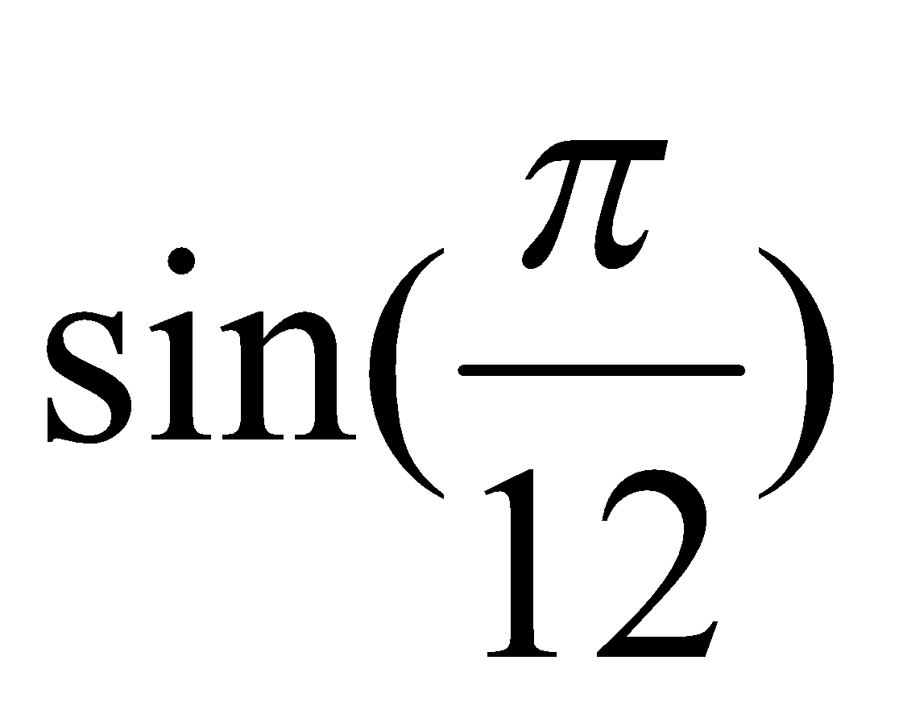 by first rewriting it in terms of special angles as 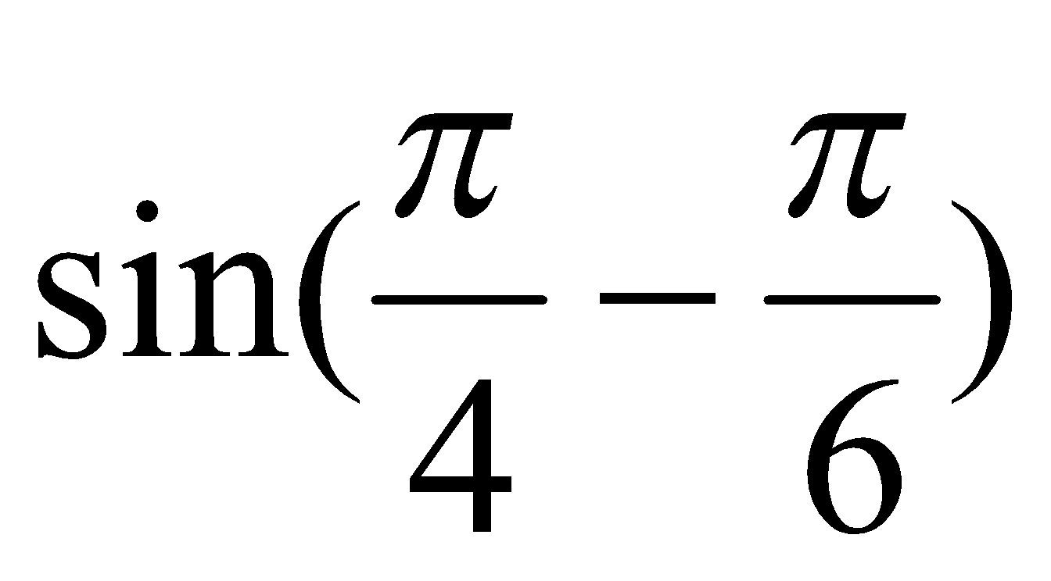] | Day 1: P.232#1ac,2bd,3ac,  4a,5a,6-8, 9ad,10  Day 2:  p. 232 #12,13,14,  15abc,20, 21, 24a
4  Proving Trig. Identities | ●recognize equivalent trigonometric expressions  [e.g., by using the angles in a right triangle to recognize that sin x and 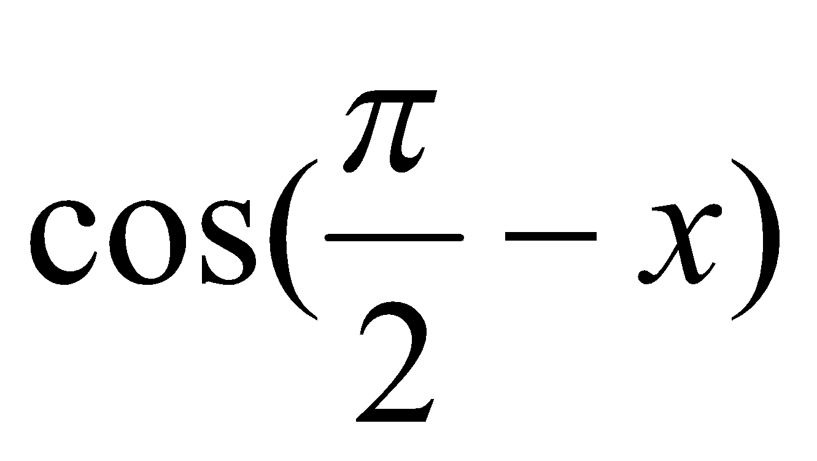 are equivalent; by using transformations to recognize that 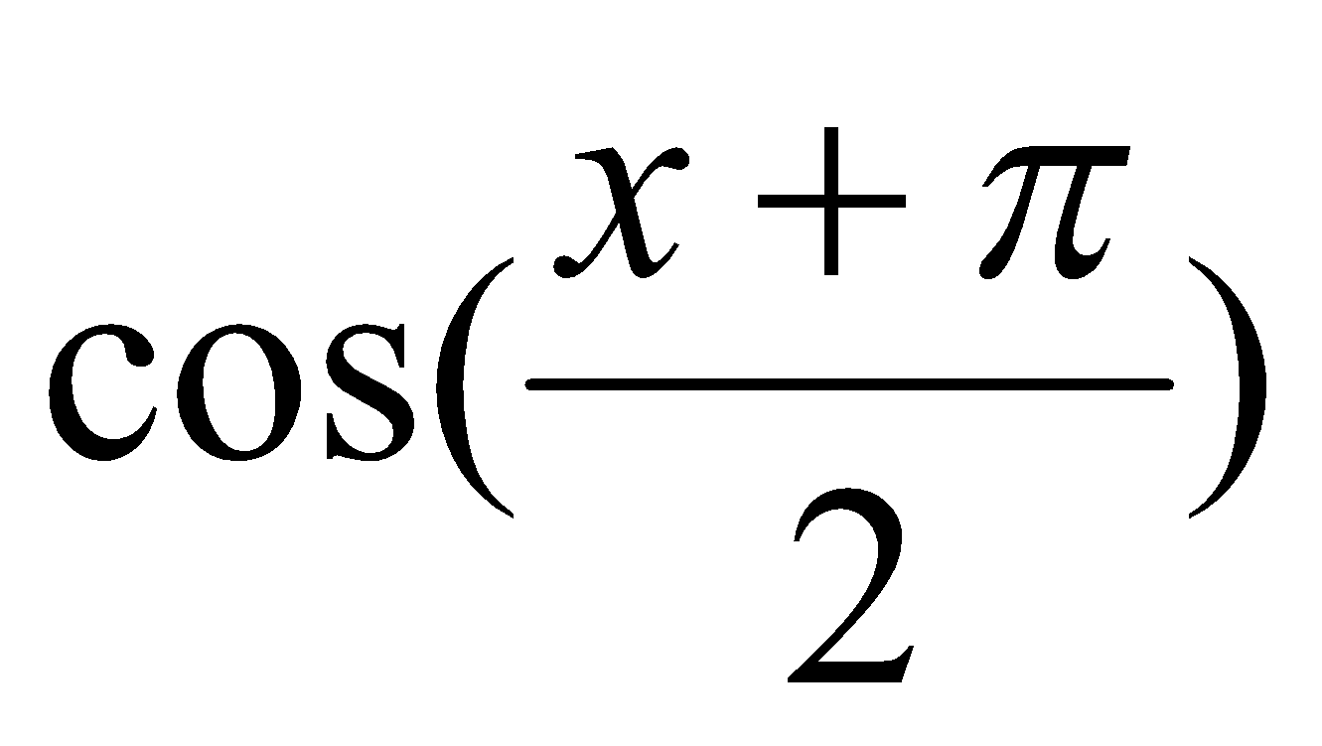 and –sin x are equivalent], and verify equivalence using graphing technology | P.240#1,3,4,8,9a,  10a,12,13,15,21
5  Proving Trigonometric Identities:  Part 2 | ●recognize that trigonometric identities are equations that are true for every value in the domain (i.e., a counter-example can be used to show that an equation is not an identity), prove trigonometric identities through the application of reasoning skills, using a variety of relationships  [e.g., tan x = (sin x/ cos x); sin² x + cos² x = 1; the reciprocal identities; the compound angle formulas], and verify identities using technology  ●Sample problem:  Use the compound angle formulas to prove the double angle formulas. | Handout
6  Review |  | Chapter 4 Review  Page244#1ad,2ad,3ac,  4c,8,9,14ad,15,16,18,  19a,20,23  Chapter 4  Practice Test  Page 246# 1-7,9,10,  12a, 13,16,17,18,19

UNIT #5-Graphing Trigonometric Functions
Lesson | Key Concept & Strategy | Textbook
1  Graphing Trig Functions (in Radians) | ●sketch the graphs of f(x) = sin x and f(x) = cos x for angle measures expressed in radians, and determine and describe some key properties (e.g., period of 2л, amplitude of 1) in terms of radians  ●make connections between the tangent ratio and the tangent function by using technology to graph the relationship between angles in radians and their tangent ratios and defining this relationship as the function  f(x) = tan x, and describe key properties of the tangent function | Handout
2  Graphing Reciprocal Trig Functions | ●determine, with technology, the primary trigonometric ratios (i.e., sine, cosine, tangent) and the reciprocal trigonometric ratios (i.e., cosecant, secant, cotangent) of angles expressed in radian measure  graph, with technology and using the primary trigonometric functions, the reciprocal trigonometric functions (i.e., cosecant, secant, cotangent) for angle measures expressed in radians, determine and describe key properties of the reciprocal functions (e.g., state the domain, range, and period, and identify and explain the occurrence of asymptotes), and recognize notations used to represent the reciprocal functions [e.g., the reciprocal of f(x) = sin x can be represented using csc x, 1/f(x), or 1/sin x , but not using f⁻¹ (x) or sin⁻¹x, which represent the inverse function] | Handout
3,4  Transformations of Trig Graphs | ●sketch graphs of y = a sin (k(x – d)) + c and y = a cos(k(x – d)) + c by applying transformations to the graphs of f(x) = sin x and f(x) = cos x with angles expressed in radians, and state the period, amplitude, and phase shift of the transformed functions  ●Sample problem:  Transform the graph of f(x) = cos x to sketch g(x) = 3 cos (2x) – 1, and state the period, amplitude, and phase shift of each function. | p. 258 #1-8 (a and d for each), 9-11
5  Sinusoidal Functions | ●represent a sinusoidal function with an equation, given its graph or its properties, with angles expressed in radians  ●Sample problem:  A sinusoidal function has an amplitude of 2 units, a period of л, and a maximum at (0, 3). Represent the function with an equation in two different ways. | P.275#1ab,2a,3,4,5a,6a,10ab,12a,13a,21
6  Solving Trig Equations | ●solve linear and quadratic trigonometric equations, with and without graphing technology, for the domain of real values from 0 to 2л, and solve related problems  ●Sample problem:  Solve the following trigonometric equations for 0 ≤ x ≤ 2л, and verify by graphing with technology:  2 sin x + 1 = 0; 2 sin² x + sin x – 1 = 0; sin x = cos 2x ; cos 2x = ½. | Pg.287  #1a,d,f,3a,c,5b,7b,c,9,11
7  Solving Trig Equations:  Part 2 | ●solve linear and quadratic trigonometric equations, with and without graphing technology, for the domain of real values from 0 to 2л, and solve related problems | Pg. 288  10,13b,c,14,16,17,20,23,25,26
8  Applications of Trig Functions | ●pose problems based on applications involving a trigonometric  function with domain expressed in radians (e.g., seasonal changes in temperature, heights of tides, hours of daylight, displacements for oscillating springs), and solve these and other such problems by using a given graph or a graph generated with or without technology from a table of values or from its equation  ●Sample problem:  The population size, P, of owls (predators) in a certain region can be modeled by the function P(t) = 1000 + 100 sin(лt /12 ), where t represents the time in months. The population size, p, of mice (prey) in the same region is given by p(t) = 20 000 + 4000 cos(лt /12 ). Sketch the graphs of these functions, and pose and solve problems involving the relationships between the two populations over time. | Handout  p. 259 #12, 13, 17, 18  p. 278 #19
9  Making Connections and Instantaneous Rate of Change |  | Page 292 - Read Example 1  Page 296 # 1,3,6,7,11,12
11  Review-Day 1 |  | Chapter 5 Review  Page 300# 1- 4, 7-12  Chapter 5 Practice Test  Page 302  # 1-7,10-14
12  Review-Day2 |  | Chapter 4 & 5 Review  Page 304# 12,13,14,16,18

UNIT #6 – EXPONENTIAL AND LOGARITHMIC FUNCTIONS
Lesson | Key Concept & Strategy | Textbook
1  Graphs of Exponential & Logarithmic Functions | ●determine, through investigation with technology (e.g., graphing calculator, spreadsheet) and without technology, key features (i.e., vertical and horizontal asymptotes, domain and range, intercepts, increasing/decreasing behaviour) of the graphs of logarithmic functions of the form f(x) = log_{b}x, and make connections between the algebraic and graphical representations of these logarithmic functions  ●Sample problem:  Compare the key features of the graphs of f(x) = log₂x, g(x) = log₄x, and h(x) = log₈ x using graphing technology.  ●recognize the relationship between an exponential function and the corresponding logarithmic function to be that of a function and its inverse, deduce that the graph of a logarithmic function is the reflection of the graph of the corresponding exponential function in the line y = x, and verify the deduction using technology | p. 318 #1, 3a, b(i), c(i), 5, 7, 8, 10, 19, 20
2  Evaluating Logarithms | ●recognize the logarithm of a number to a given base as the exponent to which the base must be raised to get the number, recognize the operation of finding the logarithm to be the inverse operation (i.e., the undoing or reversing) of exponentiation, and evaluate simple logarithmic expressions  ●Sample problem:  Why is it not possible to determine log₁₀ (– 3) or log₂0? Explain your reasoning. | P.328#1(eoo),2, 3(eoo), 4(eoo),5b, 8(eoo) 10,13
3 Solving Exponential Equations | ●solve exponential equations in one variable by determining a common base (e.g., solve 4^{x} = 8 ^{x+3} by expressing each side as a power of 2) and by using logarithms (e.g., solve 4^{x} = 8 ^{x+3} by taking the logarithm base 2 of both sides), recognizing that logarithms base 10 are commonly used (e.g., solving 3^{x} = 7 by taking the logarithm base 10 of both sides)  ●Sample problem:  Solve 300(1.05)^{n} = 600 and 2^{x+2} – 2^{x} = 12 by finding a common base or by taking logarithms, and explain your choice of method in each case. | P.368#1ac,2b,3ab,4,5,  6,10,14abd
4  Power Law of Logs | ●determine, with technology, the approximate logarithm of a number to any base, including base 10 (e.g., by reasoning that log₃29 is between 3 and 4 and using systematic trial to determine that log₃29 is approximately 3.07)  ● make connections between related logarithmic and exponential equations (e.g., log₅125 = 3 can also be expressed as 5³ = 125), and solve simple exponential equations by rewriting them in logarithmic form (e.g., solving) | P.347#1ac,2,3ac,4b,12,  17  P.375#2acfg,4acd  6,7,10,11ac,20
5  Product & Quotient Laws of Logarithms | ● make connections between the laws of exponents and the laws of logarithms [e.g., use the statement 10^{a+b} = 10ª 10^{b} to deduce that log₁₀ x + log₁₀y = log₁₀(xy)], verify the laws of logarithms with or without technology (e.g., use patterning to verify the quotient law for logarithms by evaluating expressions such as log₁₀1000 – log₁₀100 and then rewriting the answer as a logarithmic term to the same base), and use the laws of logarithms to simplify and evaluate numerical expressions | P.384#1ad,3ad,4ad,5ad,  6,7ef,9c,10b
6  Solving Logarithmic Equations | ●solve simple logarithmic equations in one variable algebraically  [e.g., log₃ (5x + 6) = 2, log₁₀ (x + 1) = 1]  ● recognize equivalent algebraic expressions involving logarithms and exponents, and simplify expressions of these types  ●Sample problem:  Sketch the graphs of f(x) = log₁₀ (100x) and g(x) = 2 + log₁₀ x, compare the graphs, and explain your findings algebraically. | P.391#2, 3, 5, 6, 9, 11a
7 Transformations of Log Functions | ●determine, through investigation using technology, the roles of the parameters d and c in functions of the form y = log₁₀ (x – d) + c and the roles of the parameters a and k in functions of the form y = alog₁₀(kx), and describe these roles in terms of transformations on the graph of  f(x) = alog₁₀x (i.e., vertical and horizontal translations; reflections in the axes; vertical and horizontal stretches and compressions to and from the x- and y-axes)  ●Sample problem:  Investigate the graphs of f(x) = log₁₀ (x) + c,  f(x) = log₁₀ (x – d),  f(x) = alog₁₀ x, f(x) = log₁₀ (kx), various values of c, d, a, and k, using technology, describe the effects of changing these parameters in terms of transformations, and make connections to the transformations of other functions such as polynomial functions, exponential functions, and trigonometric functions. | P.338#1, 2, 3cd, 5bd, 6ab, 7b,8,12, 13c
8 / 9  Applications of Exponential and Logarithmic Functions | ● solve problems involving exponential and logarithmic equations algebraically, including problems arising from real-world applications  ● Sample problem:  The pH or acidity of a solution is given by the equation pH = – logC, where C is the concentration of [H⁺] ions in multiples of M = 1 mol/L. You are given a solution of hydrochloric acid with a pH of 1.7 and asked to increase the pH of the solution by 1.4. Determine how much you must dilute the solution. Does your answer differ if you start with a pH of 2.2?  ●pose problems based on real-world applications of exponential and logarithmic functions (e.g., exponential growth and decay, the Richter scale, the pH scale, the decibel scale), and solve these and other such problems by using a given graph or a graph generated with technology from a table of values or from its equation | Handout  P.353#1bd, 2b, 6, 7, 9, 10, 11
10  Review-Day 1 |  | Chapter 6 -Review  Page 356# 1- 17 Chapter 6 Practice Test  Page 358# 1-9,11
11  Review-Day 2 |  | Chapter 7- Review  Page 408# 1- 3, 5, 7-10, 13, 14, 17abc  Chapter 7 Practice Test  Page 410# 1-6, 11-13
12  Review-Day 3 |  | Chapter 6 & 7-Review  Page 476 # 1c, 2, 4-7, 9, 10, 12-15

UNIT #7 – Combining Functions
Lesson | Key Concept & Strategy | Textbook
1  Sum & Differences of Functions  2  Products & Quotients of Functions | ●determine, through investigation using graphing technology, key features (e.g., domain, range, maximum/minimum points, number of zeros) of the graphs of functions created by adding, subtracting, multiplying, or dividing functions [e.g. (x) = 2^{-x} sin 4x, g(x) = x²+ 2^{x} , h(x) = (sinx/cosx)], and describe factors that affect these properties  ●Sample problem:  Investigate the effect of the behaviours of f(x) = sin x, f(x) = sin 2x, and f(x) = sin 4x on the shape of f(x) = sin x + sin 2x + sin 4x.  ●determine, through investigation, and explain some properties (i.e., odd, even, or neither; increasing/decreasing behaviours) of functions formed by adding, subtracting, multiplying, and dividing general functions [e.g. f(x) + g(x), f(x)g(x)]  ●Sample problem:  Investigate algebraically, and verify numerically and graphically, whether the product of two functions is even or odd if the two functions are both even or both odd, or if one function is even and the other is odd. | Lesson 1: P.424# 4-11, 14  Lesson 2: P.435# 4, 5ab, 8, 9, 15,17, 18
3  Composition of Functions | ●determine the composition of two functions [i.e., f(g(x))] numerically (i.e., by using a table of values) and graphically, with technology, for functions represented in a variety of ways (e.g., function machines, graphs, equations), and interpret the composition of two functions in real-world applications  ●Sample problem:  For a car travelling at a constant speed, the distance driven, d kilometres, is represented by d(t) = 80t, where t is the time in hours. The cost of gasoline, in dollars, for the drive is represented by C(d) = 0.09d. Determine numerically and interpret C(d(5)), and describe the relationship represented by C(d(t)).  ●determine algebraically the composition of two functions [i.e., f(g(x))], verify that f(g(x)) is not always equal to g( f(x)) [e.g., by determining f(g(x)) and g( f(x)), given f(x) = x + 1 and g(x) = 2x], and state the domain [i.e., by defining f(g(x)) for those x-values for which g(x) is defined and for which it is included in the domain of f(x)] and the range of the composition of two functions  ●Sample problem:  Determine f(g(x)) and g( f(x)) given f(x) = cosx and g(x) = 2x + 1, state the domain and range of f(g(x)) and g( f(x)), compare f(g(x)) with g(f(x)) algebraically, and verify numerically and graphically with technology.  ●demonstrate, by giving examples for functions represented in a variety of ways (e.g., function machines, graphs, equations), the property that the composition of a function and its inverse function maps a number onto itself [i.e., f ⁻¹ ( f(x)) = x and  f(f ⁻¹ (x)) = x]  ●demonstrate that the inverse function is the reverse process of the original function and that it undoes what the function does | P.447#1, 4, 8, 9, 11, 17, 18,19,21
4  Inequalities of Combined Functions | ●solve graphically and numerically equations and inequalities whose solutions are not accessible by standard algebraic techniques  ●Sample problem:  Solve: 2x² < 2^{x} ; cosx = x, with x in radians. | P.457# 3, 4, 5, 8,  9, 14, 15
5  Review |  | Chapter 8 Review  Page 472# 1, 2, 4, 6, 7, 8, 9, 10, 12  Chapter 8 Practice Test  Page 474# 1 – 5, 8, 9, 10, 13, 14  Chapter 6 to 8 Review  Page 477# 16, 18, 19, 20

Updated January 2018
Exam review:
Moodle worksheets
p. 196 #1-6, 8-25
p. 304 #1-7, 9-14, 16-20
p. 476 #1-10, 12-16, 18-20
Practice exam p. 479 #1-33, 35-46, 50-57

